



Application DEVELOPMENT Annexure

Contents

1. Application Development Scope 2

1.1 AD Capacity 2

2. DELIVERY MODEL 3

2.1 Overall Program Governance 3

2.2 Projects Planning 3

2.3 Demand Management 3

2.4 Delivery Methodology 4

2.4.1 Build Product Backlog 5

2.4.2 Release planning 5

2.4.3 Iterations/Sprints 5

2.4.4 UAT 5

2.4.5 Release and Deployment 5

2.5 Deliverables 6

3. USER EXPERIENCE (UX) 6

4. Key Responsibilities & Responsibility Matrix 7

4.1 Responsibility Matrix 11

5. Assumptions 12

6. Dependencies 12

7. Change Request Process 13

7.1 Change Request Process 13

7.2 Adding Apps to Scope 13

7.3 Benchmarking of Scope of Application 13

APPENDIX 13

List of Applications 13

Change Request Template 21

# Annexure ___

# INTRODUCTION

This is Annexure to the Statement of Work dated effective, 2018 between Essel Business Excellence Services Limited and Accenture Solutions Private Limited (the "SOW"). Capitalized terms that are defined in the SOW and not otherwise defined herein have the meanings given to them in the SOW, and grammatical variations thereof have corresponding meanings

**PURPOSE**

This Annexure describes the activities, tasks, duties, functions and responsibilities that are to be provided as part of the Application Development

# Application Development Scope

1. A Major development means an operational change to one of the existing In-Scope Applications under AD, which adds new functionality or enhances existing functionality of In-Scope Applications
2. A project means implementation of an application that is currently not present in the Essel Group application landscape.
3. Both Major Developments & Projects would
   1. Requires Accenture Project Manager to be involved in the delivery,
   2. Require skillset that are part of the existing support scope or additional new skillsets.
   3. Requires Release Management and Handover to AMS team
   4. Requires DevOps skills.
   5. Requires solution architecture and design
   6. Requires interface management
   7. Solution validations and audits.
4. Additionally, projects would
   1. Require Trainings- Train the Trainer Concept
   2. Require Hypercare or Warranty Support
5. The work location for this team will be ESSEL offices – Essel Lower Parel Mumbai and EBEX Noida

Working Hours will be 9 AM to 6 PM India Business Hours and 5 working days a week

## AD Capacity

The overall development capacity offered for AD team is **based on agreed capacity**. These development efforts are applicable for all In-scope applications including future modules on those applications. These development efforts will be used only for application developments. There are no limits on numbers of CR’s till such time they are allocated under same pool of bucket hours.

Below Capacity may be revised, post mutual agreement between Accenture & EBEX:

|  |  |  |  |  |  |
| --- | --- | --- | --- | --- | --- |
|  | **Y1** | **Y2** | **Y3** | **Y4** | **Y5** |
| FTEs | 20 | 10 | 10 | 10 | 10 |

The final list of roles operating out of Essel Offices/Onsite will be finalized during Transition Phase and the detailed skill sets in agreement with EBEX will be provided during Transition phase.

# DELIVERY MODEL

The overall program governance will be jointly managed by EBEX and Accenture. EBEX along with the Essel Group Business Entities would prioritize the Major Enhancements & Projects that need to be considered for Application Development. Accenture will then perform delivery based on the prioritized work, deliver the same and hand it over to operations.

## Delivery Methodology

Accenture will adopt delivery methodologies followed in each entity as .

## Deliverables

1. At each stage of the project development, the following deliverables will be released to EBEX.
2. Project schedule/ major development timeline
3. Design specification - updating of existing functional and technical specification documents. The updates will be made to the master document. In case of non-­ availability of the master document, Accenture will create the functional/ technical specification document for the proposed change
4. Technical architecture documentation - update to existing technical architecture documentation if any of the fix changes the underlying system architecture (where applicable). This is applicable only if architecture documents are available for those applications
5. Unit test plan
6. Unit test results
7. System integration test cases
8. System integration test results
9. Deployment plan
10. Update training documents, where applicable
11. User acceptance testing, results and sign-off will be provided by ESSEL Group.
12. Templates for all the above deliverables will be agreed during transition phase.
13. Accenture will manage the major development workload in accordance with any prioritization requirements provided by EBEX
14. Accenture will manage and implement major developments in accordance with the agreed operational change management process as documented in Section 5 of Essel IT Shared Services SOW

# DevOps

DevOps services can be majorly categorized into 4 different phases. Accenture will jointly agree with EBEX on the below DevOps plan and tool during Transition

Below is an indicative DevOps Plan which will be agreed during transition

1. Build and Deploy
2. Release Management & SCM
3. Basic Application Monitoring
4. Advanced Application Monitoring

Initially, all the strategy and process guidelines will be setup so that all the parts of SDLC are formalized.

Then, the focus will shift to implementing CI/CD for all in-scope projects.

Monitoring and feedback will be the first step where we will take the metrics and further add more automation to reduce manual effort and errors.

## Build and Deploy

Following activities will be performed as part of Build and Deploy phase

1. Requirement and Design Mapping
2. Build and Code Check In
3. Unit Test Automation
4. Code Quality Analysis and Reporting
5. Package Build and Validation
6. Deployment Automation (CD & CI)

## Basic Application Monitoring

Following activities will be performed as part of Basic Application Monitoring phase

1. Dashboard for Live Application and DB logs
2. Log Analysis by parsing the fields
3. Centralized Logging and Parsing

## Release Management & SCM

Following activities will be performed as part of Release management and SCM phase

1. Source Code Branching
2. Release Strategy
3. Deployment Strategy
4. DevOps Process Guideline
5. Code Retrofit and Auto Merge

## Advanced Application Monitoring

Following activities will be performed as part of Analytics and Digital phase

1. Integrated and Self-Healing Monitoring
2. Infrastructure/System Metrics
3. Deployment Statistics

## High Level Implementation Plan and Approach

For implementation of the DevOps solution, DevOps implementation has been divided into 4 phases.

**Exit Criteria for Phase:** Completion of Phase

**Entry Criteria for new Phase:** Successful closure of Previous Phase. Some of the activities of the subsequent phase is dependent on the previous phase for its completion while some can be worked upon in parallel.

Accenture will begin with maturity level 0% and progress towards 100%. Except ZSHOP and Essel Finance, all other entities will need implementation from Level 1. ZSHOP is already at a maturity level of 70%, and hence Accenture will only need the implementation from Level 4. Essel Finance maturity level is at 10%, hence, Accenture will do implementation from Level 2 for Essel Finance.

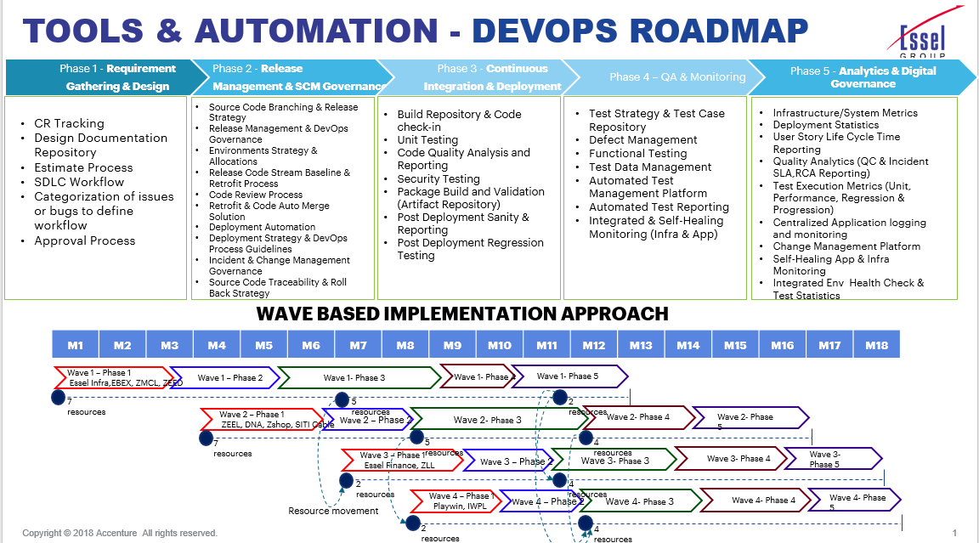

# USER EXPERIENCE (UX)

Accenture team will work on defining the User experience in terms of the layouts, the colors, branding and navigation for the Web based portals. The user will to be provided with a rich UI experience when they are browsing through the portal.

**User Experience Design**

Our approach will be to start with customers & involve them throughout the research, design & development process to deliver experiences that matter.

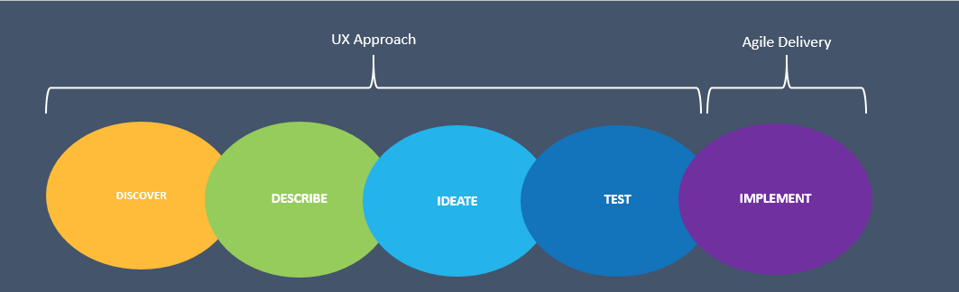

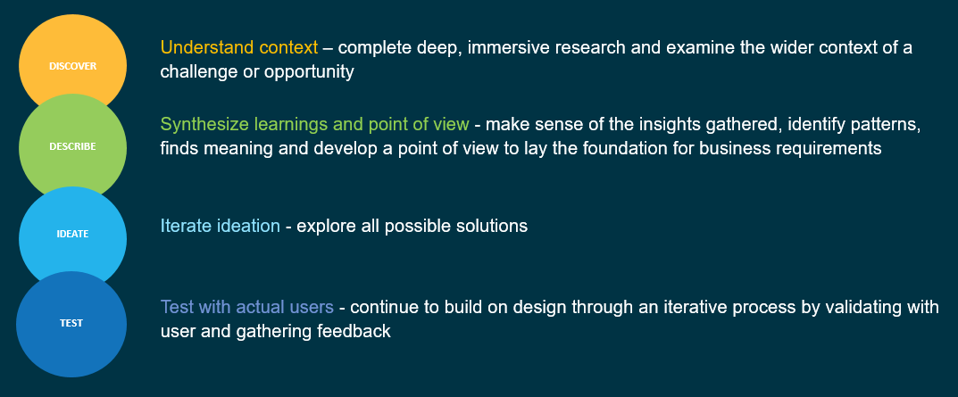

Accenture will be deploying User Experience Specialist for UX Design on Demand basis. Accenture UX Specialist will work closely with client in Discover, Describe and Ideate phase to ensure rich UI experience is delivered. Business users will be providing regular and timely feedback and approval on design to Accenture teams.

# Key Responsibilities & Responsibility Matrix

|  |  |  |  |  |
| --- | --- | --- | --- | --- |
| **#** | **Phase/ Services** | **Description** | **EBEX or ESSEL GROUP ENTITIES** | **Accenture** |
| 1 | Demand Management | • Consolidation of business demand arising from Client annual planning, quarterly planning and ad-hoc requests | • Collate demand from all the sources and lead project list maintenance |  |
| • Prioritization of application development projects as Planned, Approved and Committed projects | • Manage initiatives as they progress through the different phases from Planned->Approved->Committed | • Lead, prioritize and communicate the project’s plan (monthly) • Provide estimate, timelines, project and resource plans as appropriate for each phase. Identify dependencies between other systems/platforms are included in the estimates and timelines • Provide estimates within 5 business days to Client |
| • Effort and budget estimation of application development projects | • Review estimates and provide feedback | • Provide ROM and Actual estimates of projects as they progress through the different phases from Planned->Approved->Committed |
| 2 | Application Development Project Management | • Development and maintenance of project plan that includes key dates, key milestones, resource planning and key activities to achieve the project objective | • Provide approval on overall project Plan • Contribute towards creating the project plan by providing input | • Lead project plan development & maintenance |
| • Status update on project progress in terms of schedule, quality and cost • Management and closure of Issues/ Risks/ Actions/ Escalations at individual development project level | • Manage any escalation of issues/risks. Lead efforts to ensure issues/risks are closed appropriately to Client Standards and track decisions | • Lead overall program status for management reporting • Lead the components of the project status and ensures updates are provided in a proactive and consistent manner • Lead the management and maintenance of Issues/ Risks/Escalation/ Actions Log and lead resolution and closure processes |
| • Environment Management |  | • Ensure availability of hardware and software by working with respective Vendors and/ or Client teams. Lead and perform regular follow ups to bring back the services in stipulated time • Raise request to reserve necessary environments for development, system testing, UAT testing and pre-production where available. • Report any disruption of services by logging necessary ticket and informing concerned Client/ Vendor teams • Lead the planning/management & communication of downtimes to/for dependent platforms/technology/vendors |
| 5 | Requirements | • Business (BRS) and functional requirements (FRS) of each AD/ SI project | • Support BRS and FRS development/documentation and maintenance as per standard Client SDLC templates • Provide feedback and then provide approval prior to design initiation | • Lead BRS and FRS development and documentation. • Review and perform technical feasibility assessment of the requirements. |
| 7 | Delivery Management | • Development of Project Schedule | • Review the project schedule and provide approval | • Develop and manage the project schedule defining key tasks, start/end dates, and dependencies |
| • Project execution against schedule | • Provide inputs and direction based on risks and options • Approve the solution provided | • Communicate risks, issues, dependencies & potential impact and provide remediation solutions |
| 8 | Design | • Technical design of the application development project | • Review and provide approval | • Lead/Create/Modify the System Design Specification documents using the standard Client SDLC templates |
| 9 | Development and Documentation | • Core Development/ Customization/ Configuration and Unit Testing • Development of code migration and data conversion scripts |  | • Perform necessary code modification, core development, customization/ configuration of Custom Development and COTS software. Create/ modify SDLC documents using the standard Client SDLC templates • Develop code and unit test. Provide high level scenarios for unit testing |
| 10 | SIT | • Development of Test plan & test cases documentation |  | • Prepare test documentation for alignment with requirements. Ensure defects are recorded and tracked with planned resolution dates and solution options • Ensure testing deliverables are completed as required. Track all defects and provide planned target dates to correct defects |
| • Testing Execution | • Review SIT report and provide approval for UAT start | • Execute the SIT test scripts and report on defects. Track all defects and provide planned target dates to correct defects.  • Provide defect analysis and resolution within the project timeline |
| 11 | UAT | • User Acceptance Test of the project | • Build & execute UAT test cases and test scripts  • Provide sign off of UAT • Identify and log defects | • Resolve all the defects identified during UAT and provide resolution |
| 12 | Deployment | • Deployment Planning | • Create and manage release plan | • Identify key tasks required for deployment and confirm inclusion in overall release plan |
| • Deployment Verification |  | • Verification of deployment and business smoke test |

## Responsibility Matrix

Below is the table covering Responsibility Matrix for Application Development.

|  |  |  |  |
| --- | --- | --- | --- |
| **Application Development** | **Accenture** | **EBEX** | **ESSEL GROUP ENTITIES** |
| **Demand and Capacity Management** | | |  |
| Raise Demand |  |  | X |
| Prioritize Demand |  | X |  |
| Demand Estimation | X |  |  |
| Assign capacity for the demand | X |  |  |
| Monitor and progress reporting | X |  |  |
| **DELIVERY** | | |  |
| Requirement Gathering | X |  |  |
| Requirements Sign Off |  | X | X |
| Solution Design | X |  |  |
| Solution Design Sign Off |  | X | X |
| Project Plan | X |  |  |
| Build | X |  |  |
| Unit Testing | X |  |  |
| System Testing | X |  |  |
| System Integration Testing | X |  |  |
| User Acceptance Testing |  |  | X |
| UAT Sign Off |  |  | X |
| Deployment Document and Operations Handover | X |  |  |
| Knowledge Management and Training | X |  |  |

1. Responsibility Matrix for Application Development

# Assumptions

* .
* Accenture team will document functional requirements for delivery of scope and Essel Business team to sign off Functional Requirements Specification within 10 working days from submission date.
* Accenture team to submit design for sign-off which will be approved by respective Essel Group Entity’s Project Manager within 7 working days of submission. Any exceptions to latter will be notified to Accenture in writing. Any changes proposed in technical design post baseline of design will be considered as a new demand on top of current scope.
* Respective ESSEL Group will provide sign-off for UAT for production deployment as per the mutually agreed Project and UAT timelines. Any exceptions to latter will be notified to Accenture in writing.
* Each man-day of development is assumed to be the Standard client working day.
* Essel entities will ensure that dependencies from Essel for DevOps adoption and rollout will be completed within timelines to ensure delivery is done as per implementation timelines captured in Section 4.5

# Dependencies

* Client specific system access and authorizations are available for the resources. User Access Management Process will be built as part of Transition phase
* All communications and documentation will be in English
* Should there be an extension to schedule or change in assumptions, Essel group entities will initiate a change request
* Availability of Test User ID’s for SIT and UAT. Accenture team will confirm if the Test User ID are functional before SIT and UAT dates. Test User ID creation process in Essel Group environments will be built as part of Transition Phase
* Port and Connectivity details in case of changes in server or path details before SIT, UAT and Production will be provided to the Development team and Testing in coordination with the Accenture Infrastructure team.
* Environment should be up and ready and there is no /limited downtime